Answer 1) 891 12

(the dataset has 891 observations of 12 variables)

Answer 2) 29.69912 (Average Age)

Answer 3)

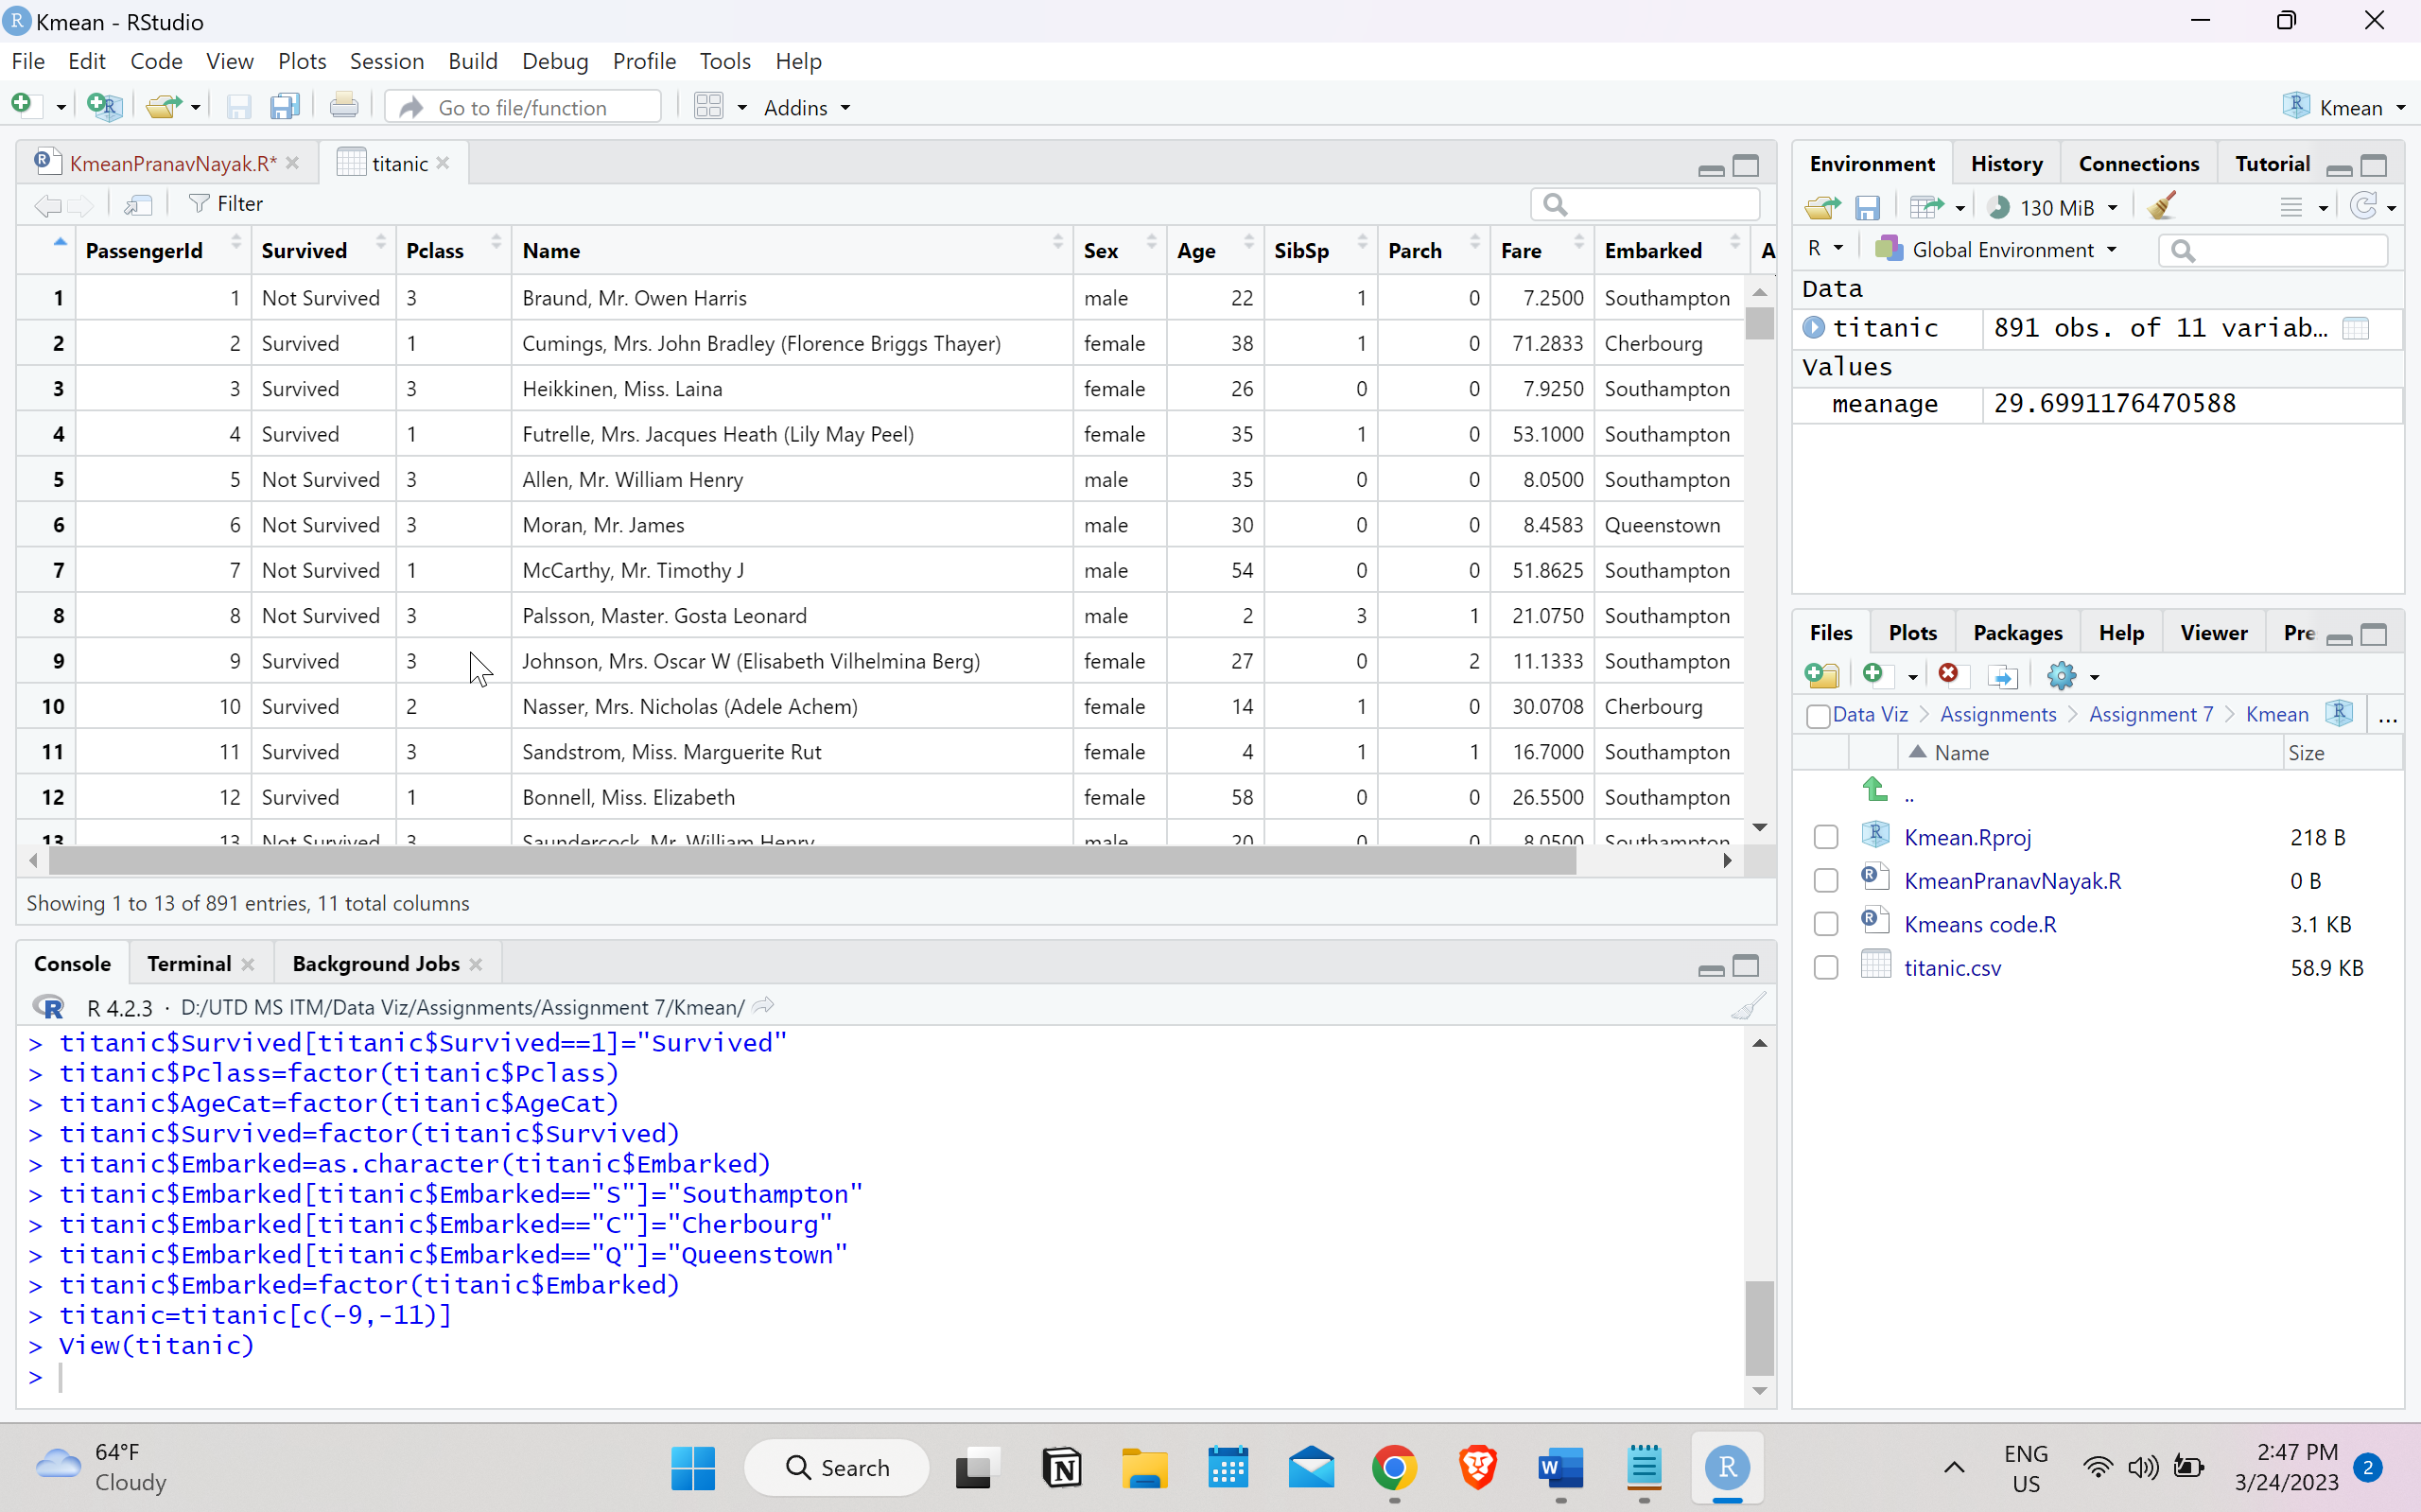sss

Answer 4)

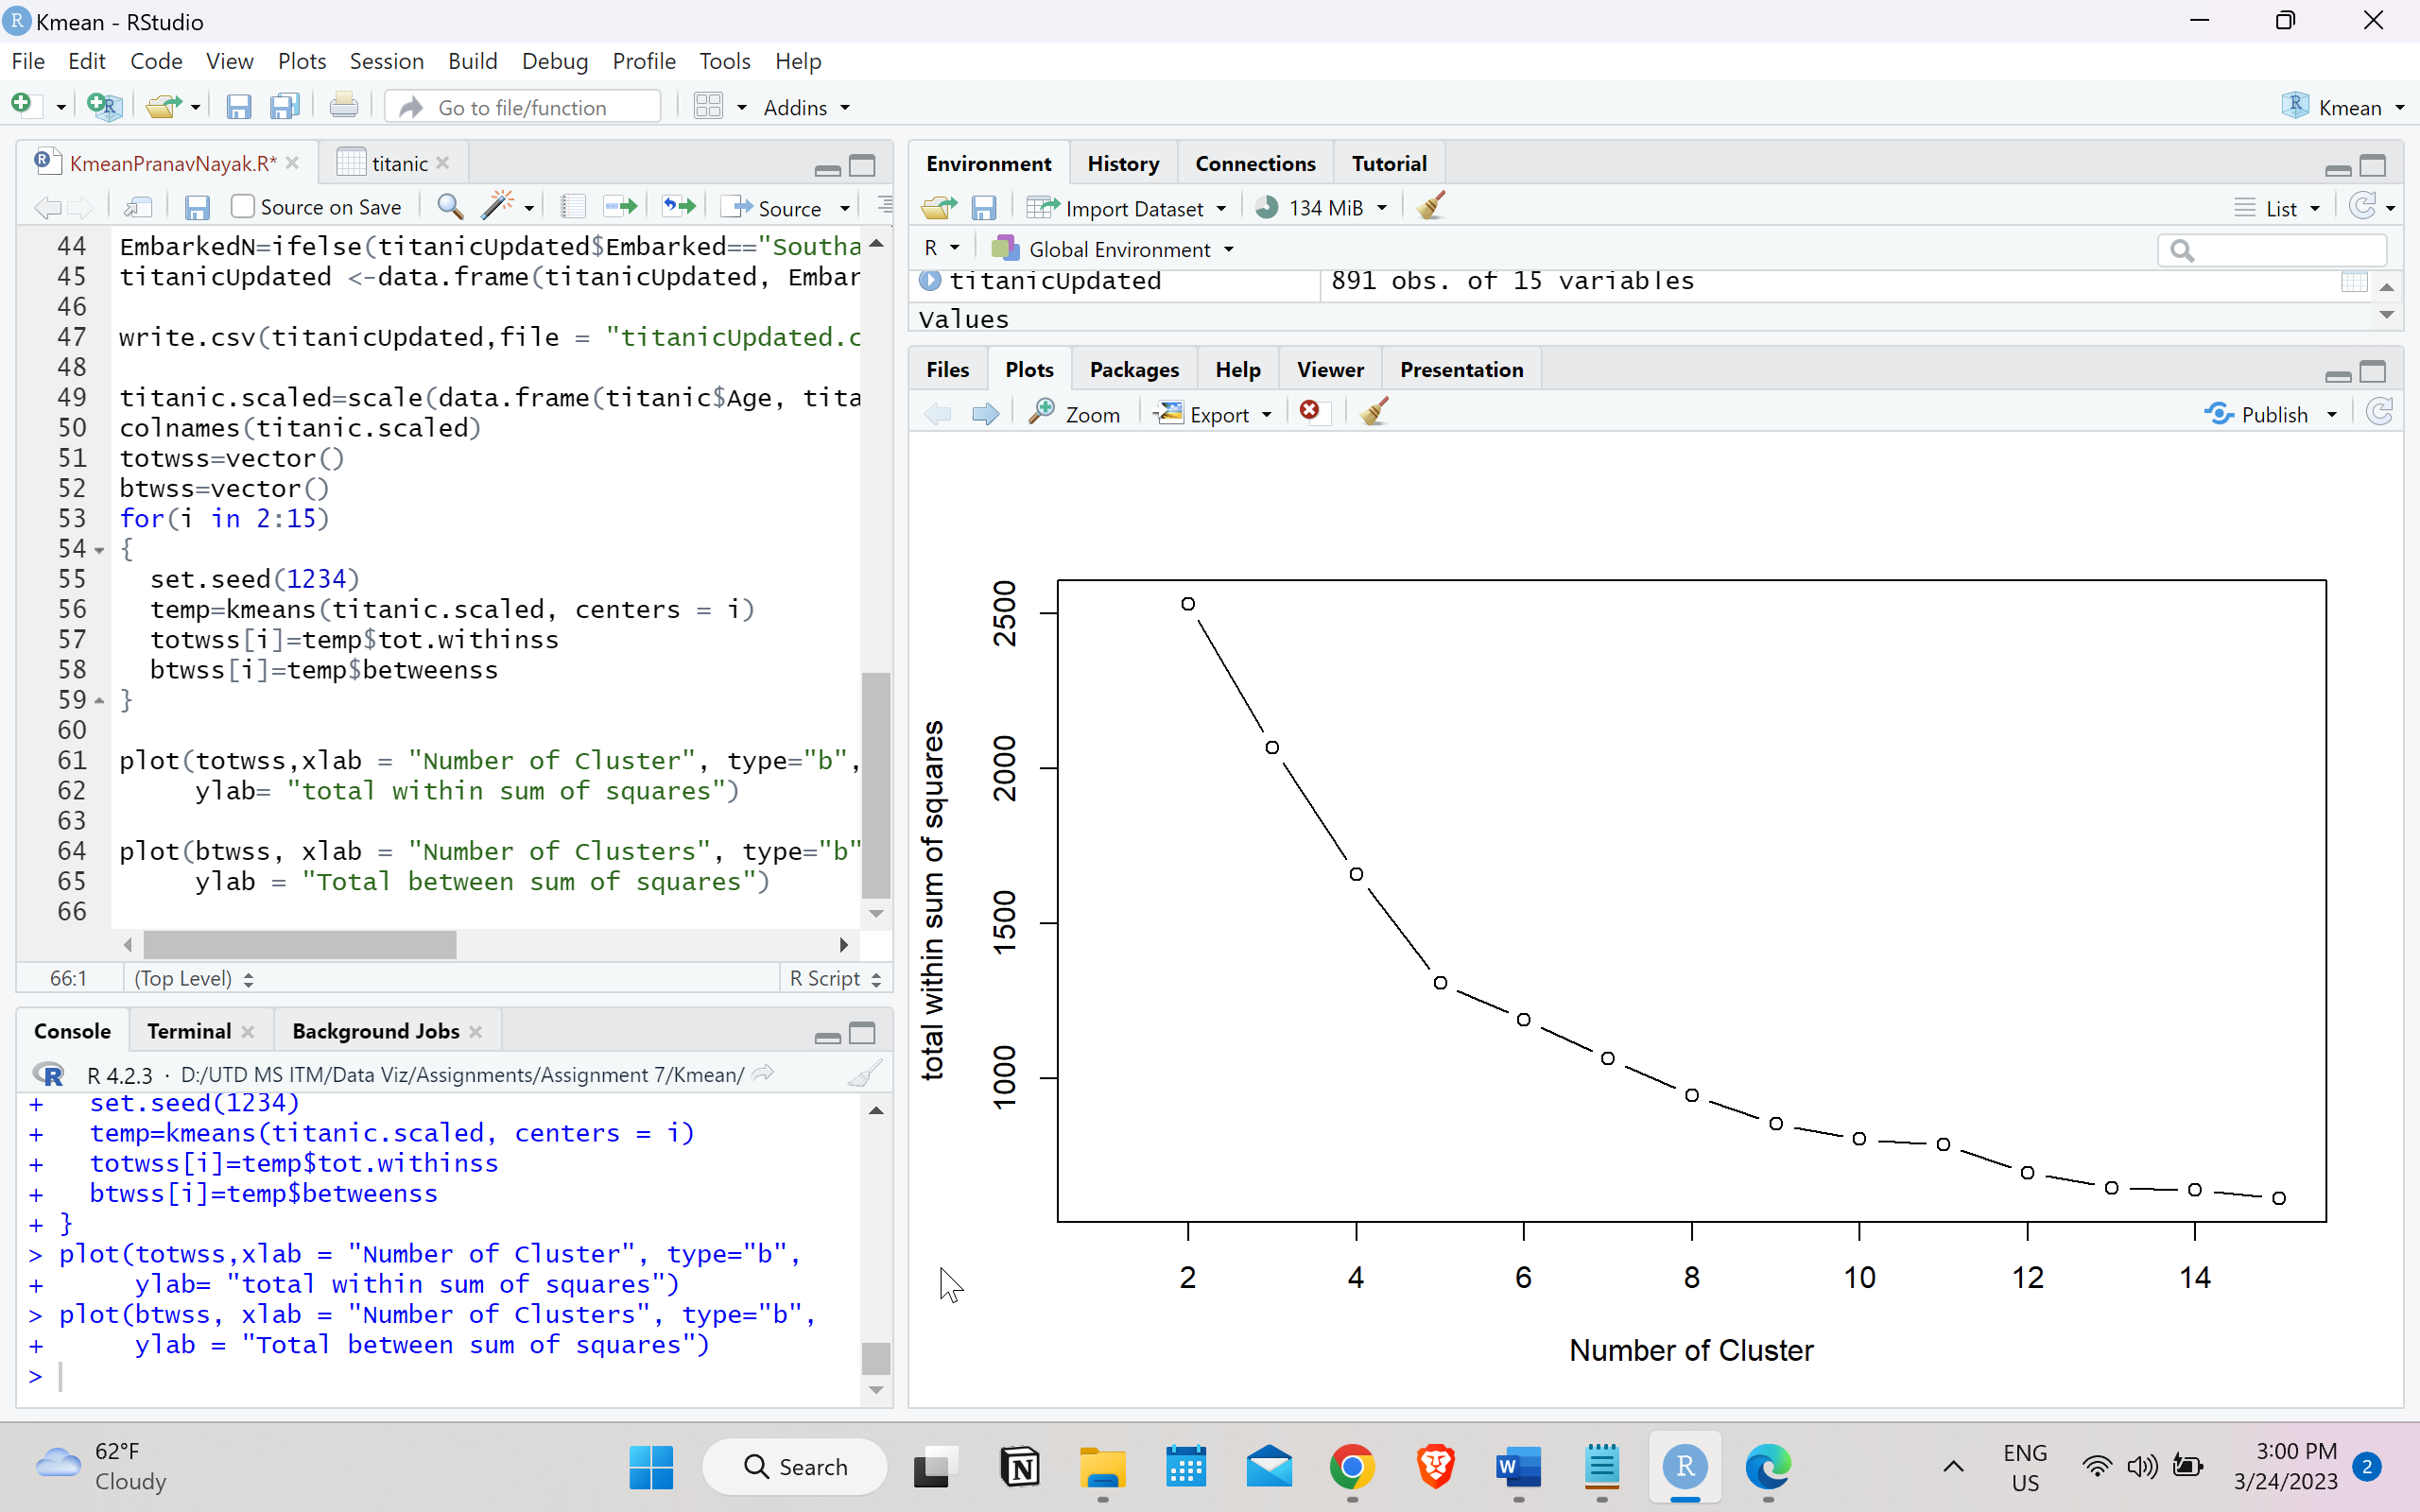

Answer 5)

Through the elbow method I have chosen 5 clusters

Answer 6)



Answer 7)

Answer 8)

Answer 9)

Answer 10)

* From cluster 1 it can be observed that most people who are in the “not survived” section are in range of 11 to 41 with some outliers. Also, the people who survived had an age range of 1 to 45.
* People who survived mainly from Southampton and people who did not survive were from Southhampton and Queenstown.
* Passengers from classes 2 and 3 had similar chances of both surviving and not surviving.
* the passengers who belonged to “not survived” category embarked from 3 ports namely Cherbourg, Southampton, and Queenstown while those who survived are from Southampton and Queenstown

Answer 11)

* Most passengers that survived belonged to Cherbourg and Southampton and people who did not survive were mainly from Chebourg.
* In Cluster 4 the age distribution of people who did “not survived” is from 9 to 45 and for people who survived is 0 to 58
* The survivors belong to Pclass 1,2 and 3 and people who did not survive belonged to Pclass 3

Answer 12)

Answer 13)

Survivability is highest in clusters 3 and 4.

Answer 14)

|  |  |  |
| --- | --- | --- |
|  | Cluster 3 | Cluster 4 |
| Ideal Gender |  |  |
| Ideal Passenger Class |  |  |
| Ideal Age Category |  |  |
| Ideal Embarked point |  |  |
| Ideal number of siblings |  |  |

Answer 15)

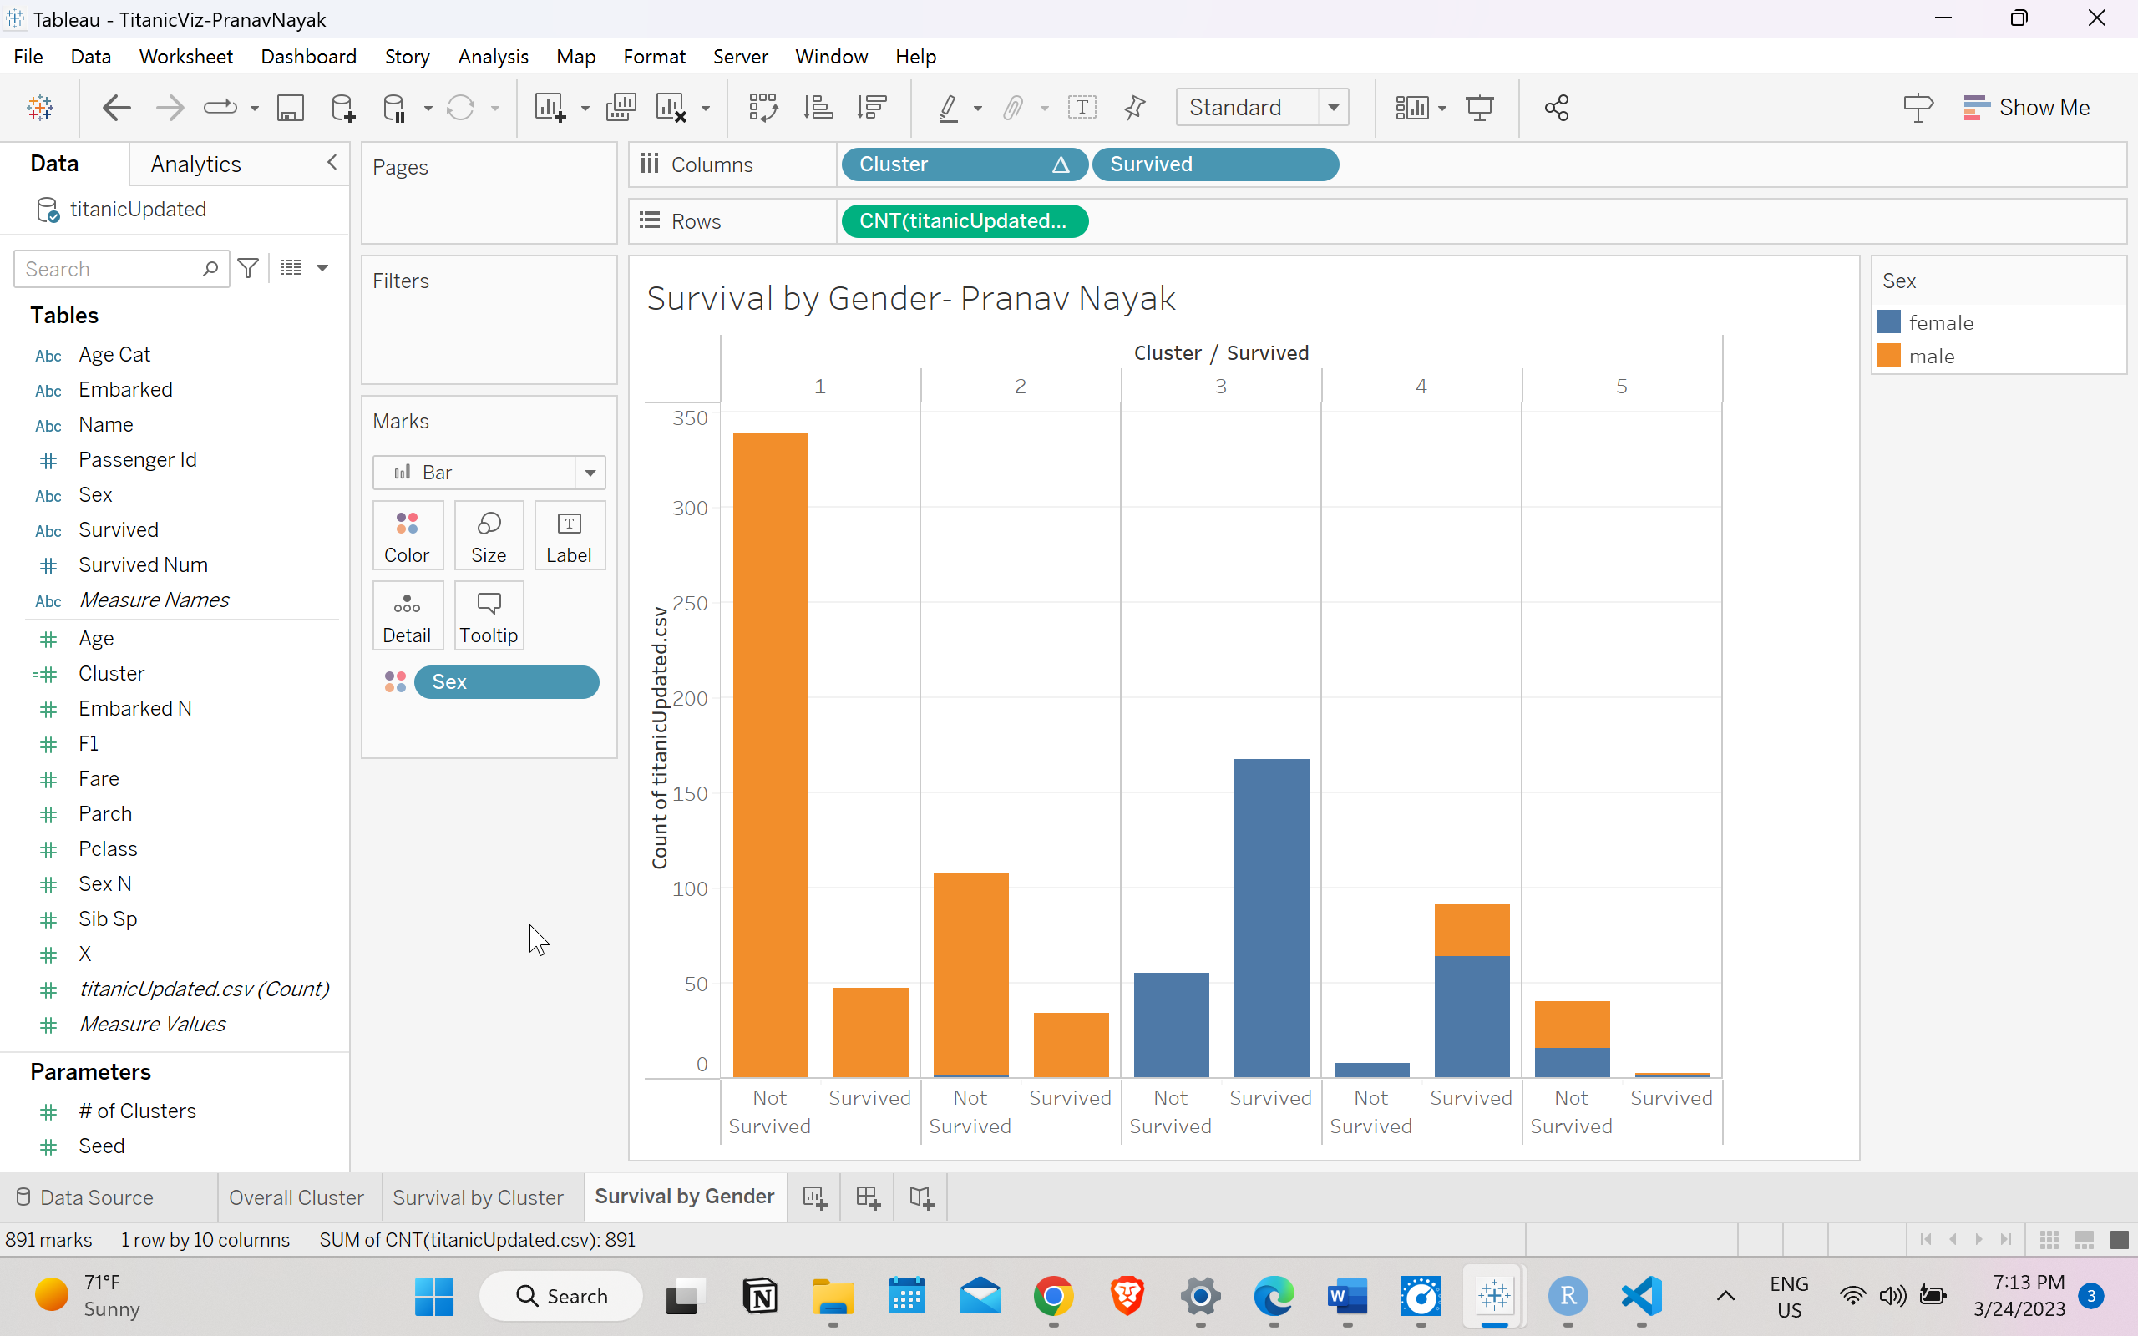

Answer 16)

For females, Cluster 3 has the highest survival probability.

Answer 17)

|  |  |  |
| --- | --- | --- |
|  | Cluster 3 | Cluster 4 |
| Ideal Gender | Female | Female |
| Ideal Passenger Class |  |  |
| Ideal Age Category |  |  |
| Ideal Embarked point |  |  |
| Ideal number of siblings |  |  |

Answer 18)

Answer 19)

|  |  |  |
| --- | --- | --- |
|  | Cluster 3 | Cluster 4 |
| Ideal Gender | Female | Female |
| Ideal Passenger Class | Pclass 2 | Pclass 1 |
| Ideal Age Category |  |  |
| Ideal Embarked point |  |  |
| Ideal number of siblings |  |  |

Answer 20)

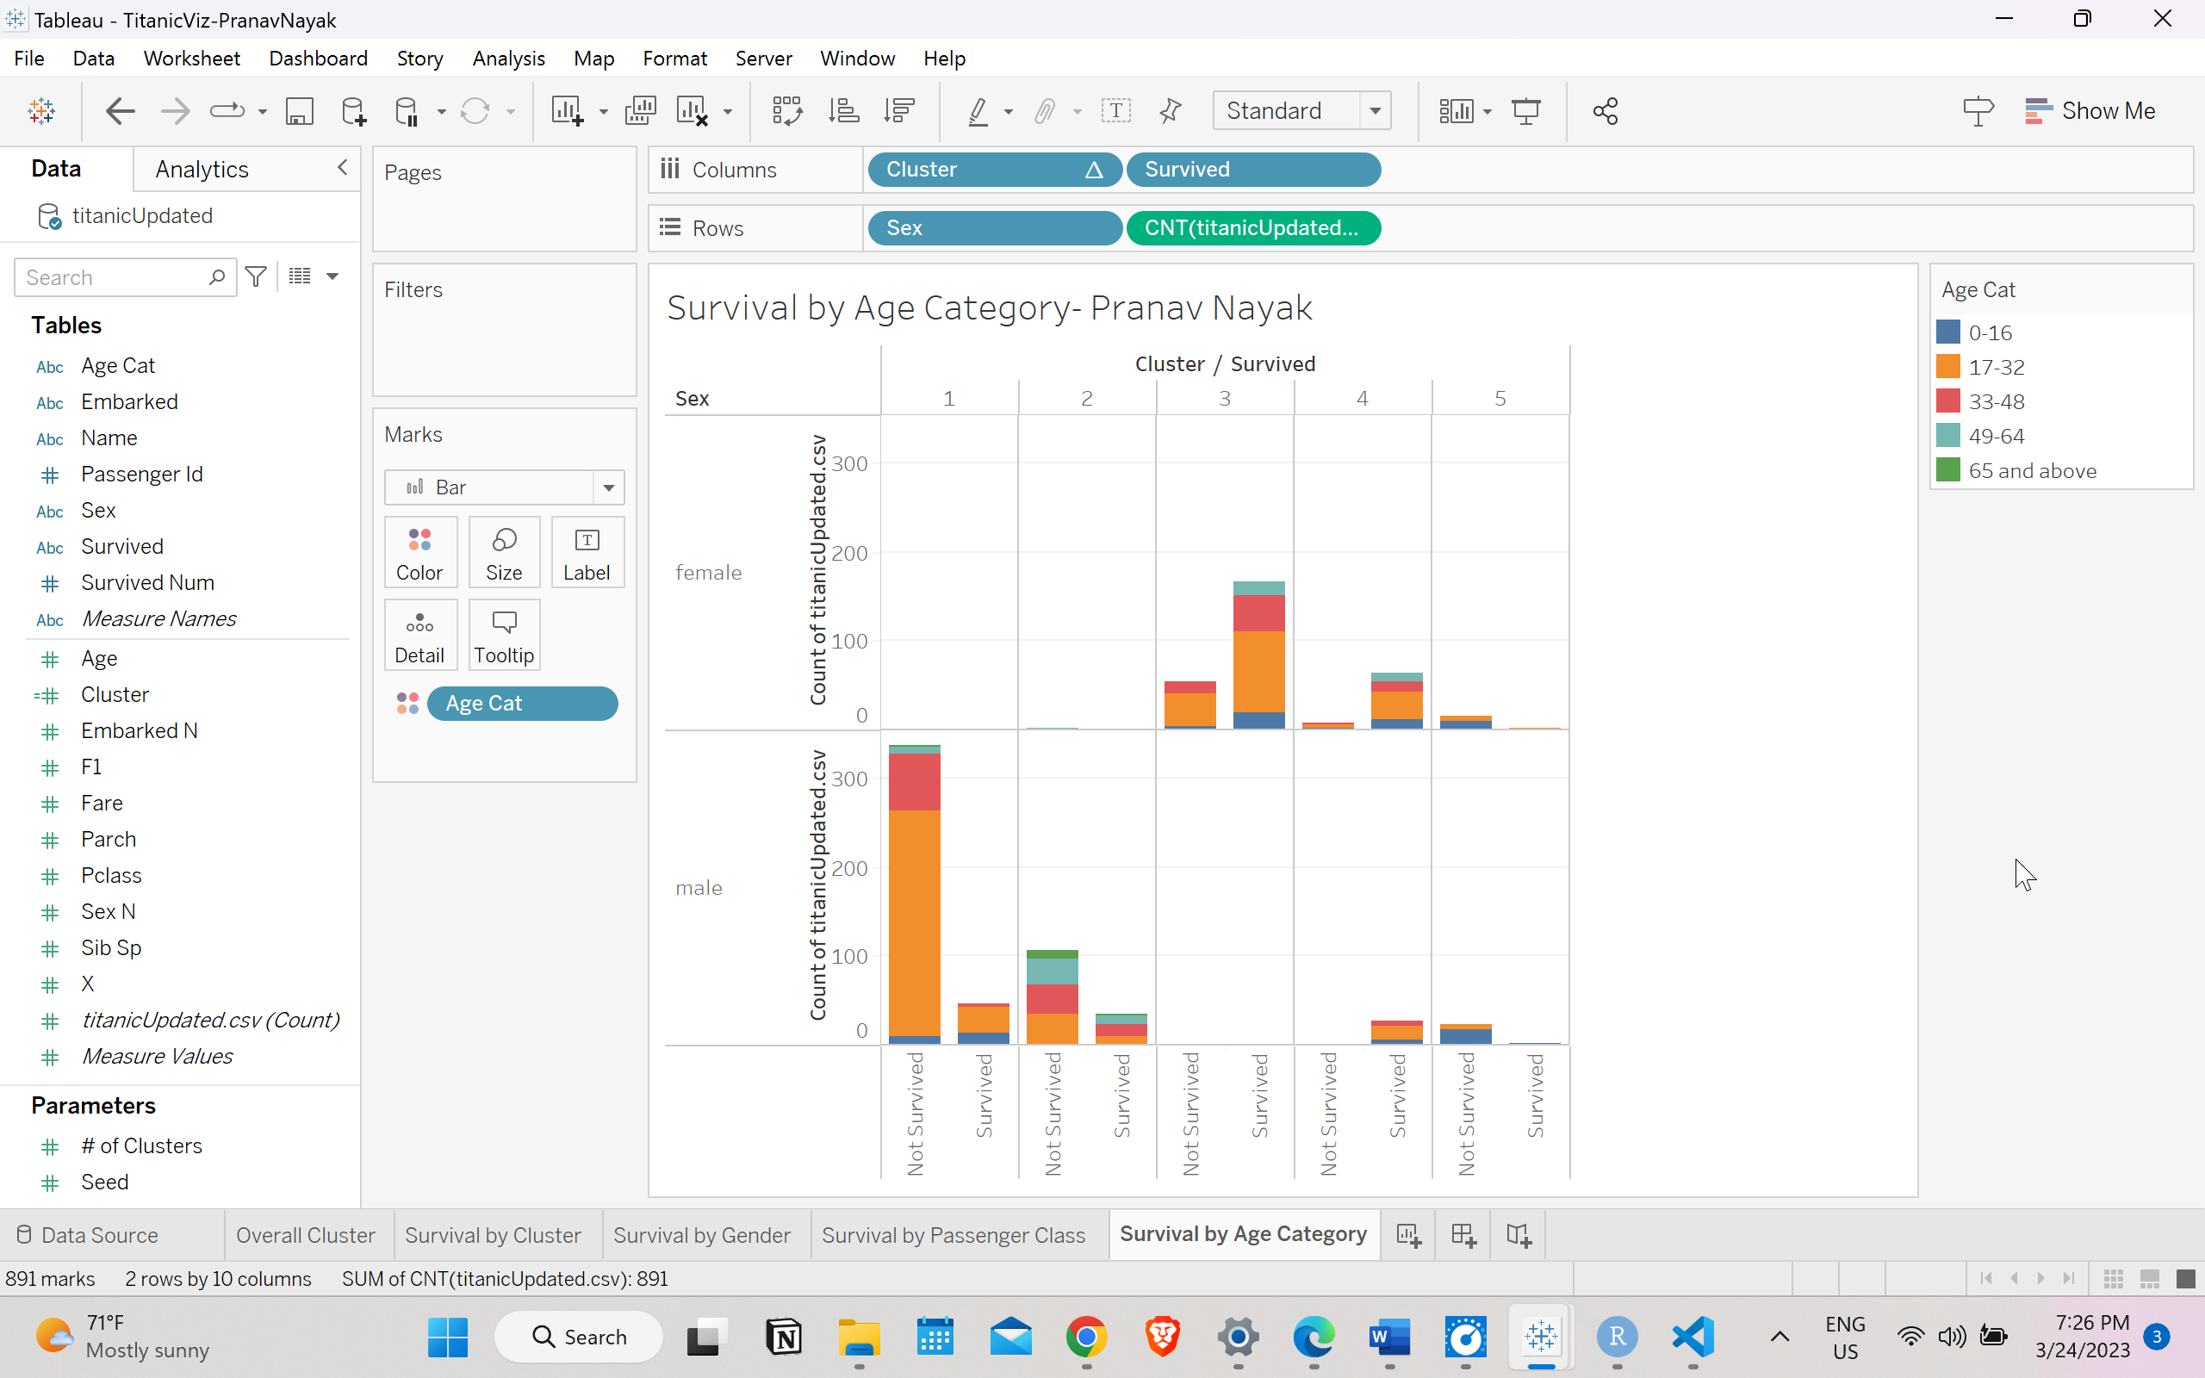

Answer 21)

|  |  |  |
| --- | --- | --- |
|  | Cluster 3 | Cluster 4 |
| Ideal Gender | Female | Female |
| Ideal Passenger Class | Pclass 2 | Pclass 1 |
| Ideal Age Category | 17 -32 years | 17 -32 years |
| Ideal Embarked point |  |  |
| Ideal number of siblings |  |  |

Answer 22)

Answer 23)

|  |  |  |
| --- | --- | --- |
|  | Cluster 3 | Cluster 4 |
| Ideal Gender | Female | Female |
| Ideal Passenger Class | Pclass 2 | Pclass 1 |
| Ideal Age Category | 17 -32 years | 17 -32 years |
| Ideal Embarked point | Southampton | Cherbourg |
| Ideal number of siblings |  |  |

Answer 24)

Answer 25)

|  |  |  |
| --- | --- | --- |
|  | Cluster 3 | Cluster 4 |
| Ideal Gender | Female | Female |
| Ideal Passenger Class | Pclass 2 | Pclass 1 |
| Ideal Age Category | 17 -32 years | 17 -32 years |
| Ideal Embarked point | Southampton | Cherbourg |
| Ideal number of siblings | Zero | Zero |

Answer 26)

Cluster 3:

The data shows that passengers with the highest survival chance belong to cluster 3 that were majorly women in the 17-32 age group. They belonged to the second class and embarked from Southampton. They traveled alone without siblings.

Cluster 4:

Passengers with the highest survival probability and who belonged to cluster 4 were females between the age group of 17 to 32 years that were categorized in passenger class 1. The majority of them boarded from Cherbourg and didn't have any siblings